SQL COMMANDS USED [documentation]
#created a new database
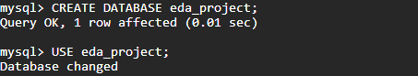
#checking security variables
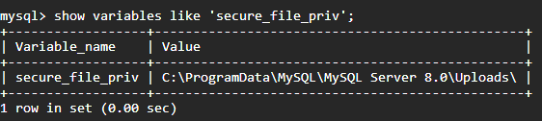
#table creation for the excel cleaned data.
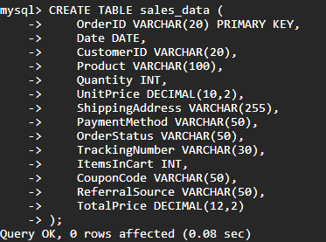
#describing the schema
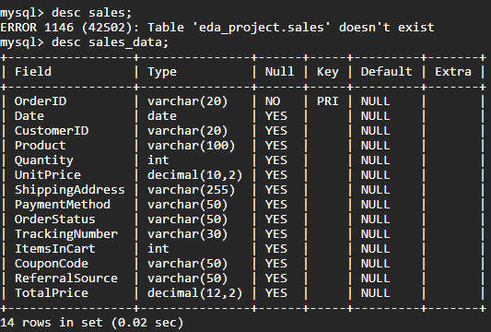
VIEW THE DATA
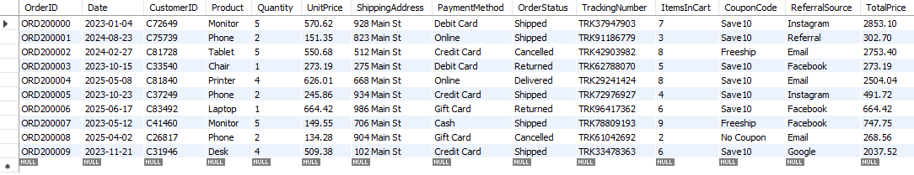
SELECTING SPECIFIC COLUMNS
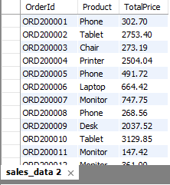
ORDERS ABOVE 1000
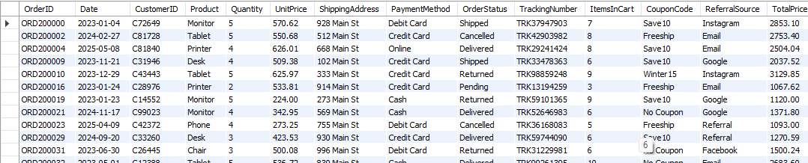

COMPLETED ORDERS
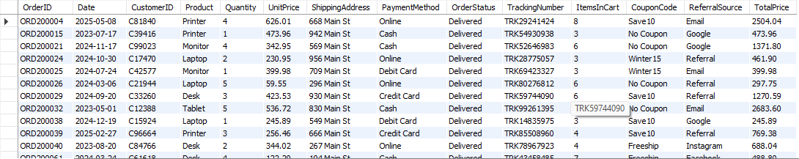
CARD PAYMENTS
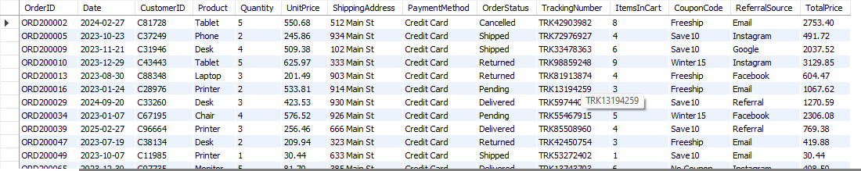

ORDER BY
HIGHEST SALES FIRST
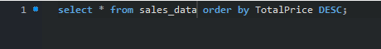
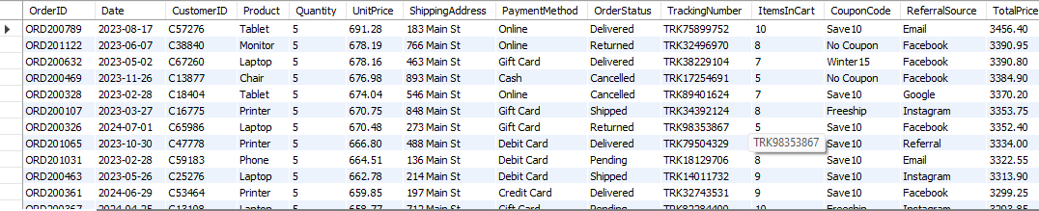
LOWEST SALES FIRST
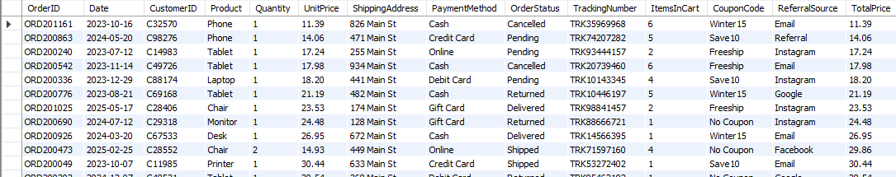

LATEST ORDERS

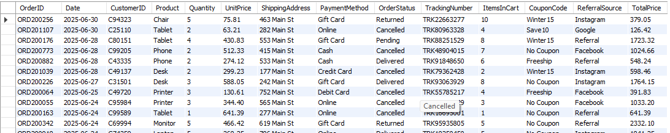
COUNT()
TOTAL ORDERS

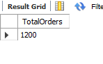
DELIVERED ORDERS
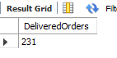
SUM()
TOTAL REVENUE
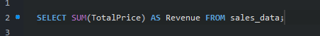
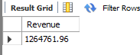
AVG()
AVERAGE ORDER VALUE
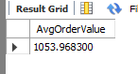
AVERAGE QUALITY
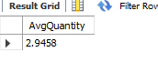
GROUP BY
REVENUE BY PRODUCT
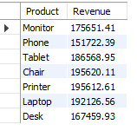
ORDERS BY PAYMENT METHOD
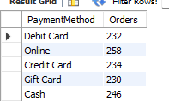
ORDER BY STATUS
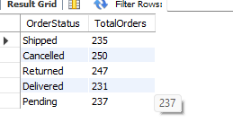
GROUP BY + ORDER BY
TOP PRODUCTS BY REVENUE
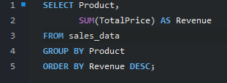
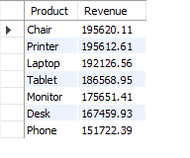
GROUP BY +AVG
Average order value per payment method
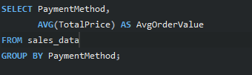
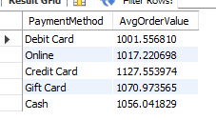

HAVING
Products generating more than ₹5000 revenue
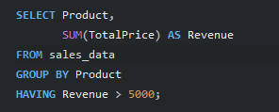
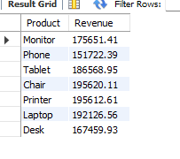
Payment methods with more than 50 orders
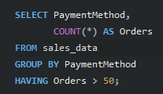
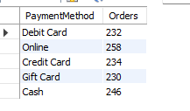
AS (aliases)
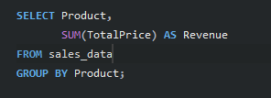
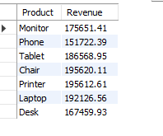
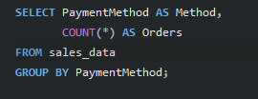
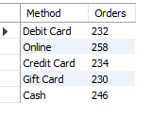
COMBINED QUERY
